STUDENT COMPULSORY INTERNSHIP REPORT AND ASSESSMENT QUESTIONNAIRE
INFORMATION ABOUT STUDENT PRACTICAL ACTIVITIES DURING THE INTERNSHIP PERIOD

State the goal of the internship:
Indicate what activities you carried out during the tasks of the internship plan:
Task nr. 1 : | The following activities were carried out during the reporting period:
Task nr. 2: | The following activities were carried out during the reporting period:
Task nr. 3: | The following activities were carried out during the reporting period:
Task nr. 4: | The following activities were carried out during the reporting period:
Describe what results you have achieved, where and how you will apply it:
Describe what competencies you have acquired / improved:
Describe the benefits received by the host organization. How will the results of the internship be applied in the host organization?
Identify what knowledge, abilities and skills you lacked during this internship period:
Identify the most valuable experience and explain why its valuable?

EVALUATION OF THE PERFORMANCE OF THE INTERNSHIP INSTITUTION

To what extent did the internship allow you to get acquainted with and understand the problems related to the activities of the internship institution?
Identify two most important problems related to the activities of the internship institution and explain them on the basis of the theoretical knowledge acquired during the studies:
Provide recommendation for resolving problems related to the activities of the practice institution:

INFORMATION ON THE EVALUATION OF THE INTERNSHIP

Assessment of professional knowledge acquired during the internship:  (on a scale of 1 to 5: 1 = poor, 5 = excellent) |  | 1 | 2 | 3 | 4 | 5
Assessment of personal achievements during internship:  (on a scale of 1 to 5: 1 = poor, 5 = excellent) |  | 1 | 2 | 3 | 4 | 5
In what aspects would you particularly appreciate your internship? | academic (compulsory part of studies)  relevant work experience  acquisition of new professional knowledge and skills  cultural  improving foreign language skills  future career plans / employment opportunities  independence  others (please specify specific):
During internship have you learn new techniques, technologies and methods? |  | Yes No
Do you think internship is going to help you in your further career?  (on a scale of 1 to 5: 1 = will not help, 5 = will help a lot) |  | 1 | 2 | 3 | 4 | 5
Do you think that internship is going to help you to get a job?  (on a scale of 1 to 5: 1 = will not help, 5 = will help a lot) |  | 1 | 2 | 3 | 4 | 5
General assessment of the practice:  (on a scale of 1 to 5: 1 = poor/ negative, 5 = excellent) |  | 1 | 2 | 3 | 4 | 5

INFORMATION ABOUT THE SUPERVISION OF STUDENT PRACTICAL ACTIVITIES DURING THE REPORTING PERIOD

Please mark your rating
Evaluate the assistance of the internship supervisor in the host organization during the reporting period:
Comment on the means and frequency of communication with the internship supervisor in the host organization:
During the reporting period of the university internship supervisor's assistance:
Please comment:
Indicate the problems you encountered during the internship period:
If you encounter problems, describe the solutions:
Would you recommend an internship at this institution for other students? Why?

STUDENTS‘ SELF-ASSESSMENT

Please mark your rating |  | 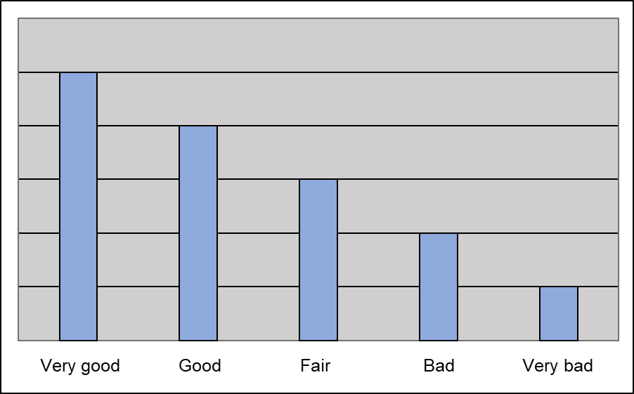
Evaluate your attitude to work (initiative, enthusiasm):
Assess your academic readiness to complete the assigned tasks:
Evaluate your ability to solve emerging problems:
Evaluate your time management ability:
Evaluate your ability to plan and organize work:
Evaluate your ability to collaborate with colleagues and professionals in other fields:
Evaluate the ability to work with a supervisor:
Evaluate your ability to accept criticism and respond constructively to it:
Evaluate the effectiveness of your communication skills:
Did you achieve your internship goals? Explain why:
Did you feel part of the team and why? What helped you, and what hindered you from successfully joining the team?
What grade would you rate your work in the internship institution and why?

CONCLUSIONS AND SUGGESTIONS FOR IMPROVING THE ORGANIZATION OF INTERNSHIP

