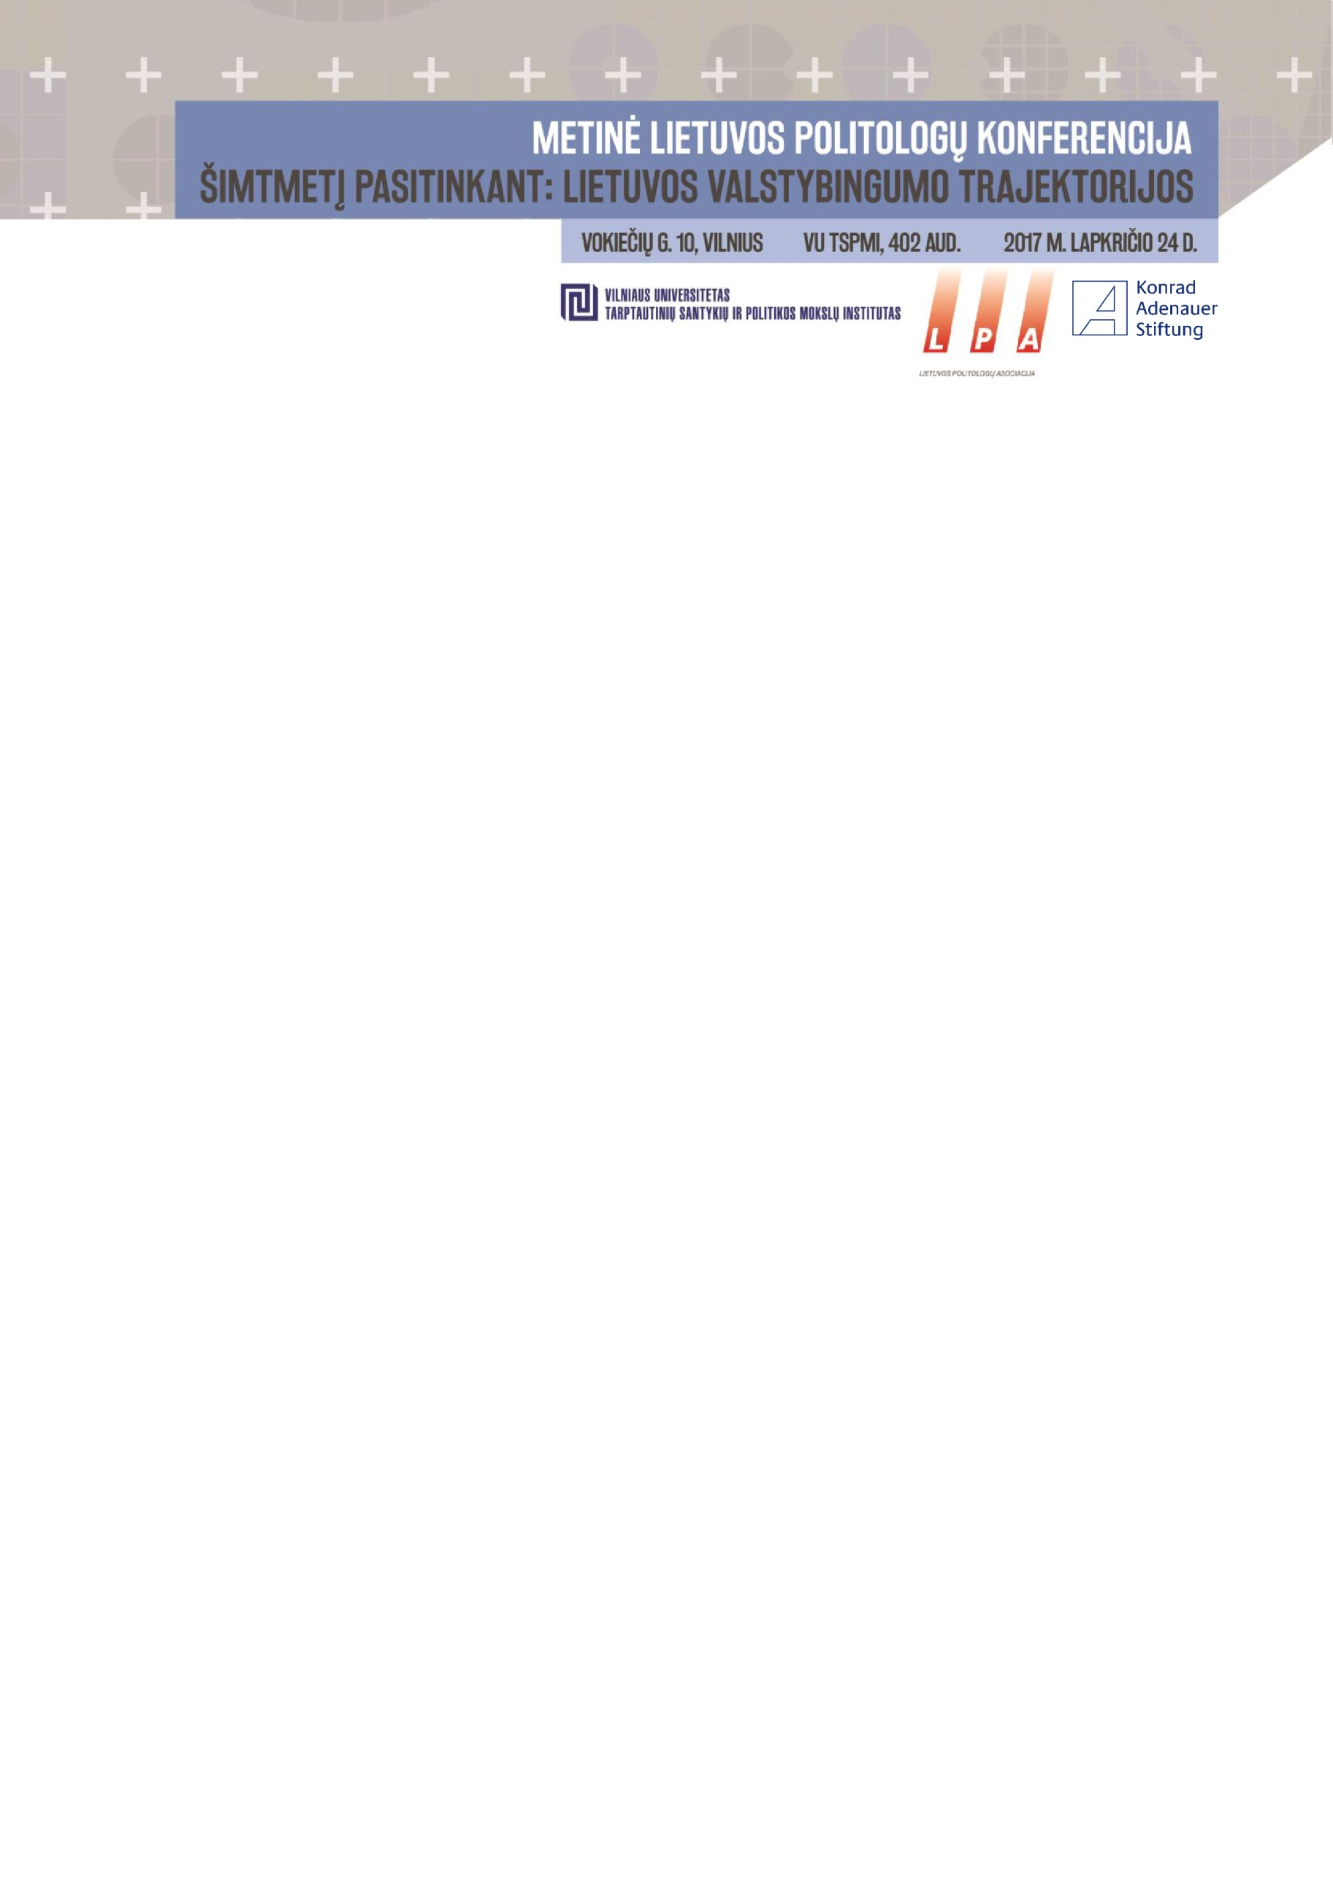

|  |  |
| --- | --- |
| 9.00-10.45 | **HOW TO IMAGINE A STATE? OR (CONTRA)ROMANTIC IDEOLOGY OF POLITICAL COMMUNITY**  Moderator: **Lauras Bielinis**  **Alvydas Jokubaitis*****,*** *„Why romanticism is destroying statesmen?“*  **Linas Jokubaitis****,** *„Lesson from romanticism: the importance of illusions for politics“*  **Justinas Dementavičius****,** *„The legacy of tradition: the state of Lithuania and romantic conservatism“*  **Nerija Putinaitė****,** *„Lithuanian song and dance festival: a monument for the alliance of the nation and romanticism?“*  Comments and discussion |
| 10.45-11.00 | Coffee break |
| 11.00-12.30 | **HOW TO PROTECT A STATE? THE CHALLENGES FOR SOVEREIGNITY AND ROLE OF CITIZENS**  Moderator: **Liutauras Gudžinskas**  **Ainė Ramonaitė****,** *„Liberals or conservatives: who is going to defend our homeland? Civil resistance and its assumptions“*  **Petras Ragauskas****,** *„Systemic corruption as a denial of state‘s sovereignity“*  **Vytautas Kuokštis,** *„Fiscal morality in Lithuania“*  **Karolis Dambrauskas,** *„Lithuanian Poles and their relations with the state“*  Comments and discussion |
| 12.30-13.45 | **Lunch break** |



|  |  |  |
| --- | --- | --- |
| 13.45-15.15 | **HOW TO BE A STATE? IN SEARCH OF POLITICAL ORGANIZATION FORMS**  Moderator: **Alvydas Jokubaitis**  **Raimundas Lopata,** „*Some remarks on restoration of Lithuanian statehood in 1918*“  **Vytautas Radžvilas,** *„Nation state: relic of the past or indispensable form of political organization?“*  **Algimantas Jankauskas****,** *„Antanas Smetona and his perception of Lithuanian freedom or what do we know about the authoritarianism of interwar Lithuania?“*  **Liutauras Gudžinskas,** *„Changing the paradigm of Lithuanian politics: returning the memory of interwar left“.*  Comments and discussion | |
| 15.15-15.30 | Coffee break | |
| 15.30-17.00 | **PRESENTATION OF THE BOOK: HOW TO BECOME A STATE: SPACES AND TERRITORIES IN GEORGIAN TERRITORIAL CONFLICTS**  Moderator: **Laurynas Jonavičius**  Participants: **Dovilė Jakniūnaitė, Erika Leonaitė, Vytis Jurkonis, Giedrius Česnakas**  Comments | |
| 17.00-18.00 | Lithuanian Political Science Association‘s (LPA) meeting  (LPA members only, room 104) | Farewell |
| 18.00-19.00 | Farewell |