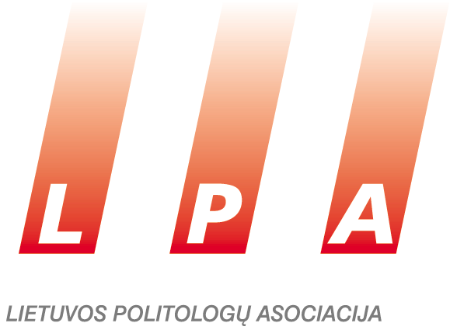

**making democracy work:**

**political institutions in lithuania and their reforms**

**Annual Conference**

**November 21 (Friday), 2014**

*Venue:**IIRPS VU Conference Hall (4th floor), Vokiečių str. 10, Vilnius*

**9.00–9.20 Welcoming speeches**

* Prof. Ramūnas Vilpišauskas, Director of Institute of International Relations and Political Science
* Dr. Liutauras Gudžinskas, President of Lithuanian Association of Political Scientists
* **Awarding the author of the best publication of 2014**

**9.20–10.10 SESSION I. Experiencing Democracy and its Contradictions**

*Moderator: Dr. Liutauras Gudžinskas, Institute of International Relations and Political Science*

* Prof. Alvydas Jokubaitis, Institute of International Relations and Political Science. ***Why Does Democracy Ruin its own Intentions?***
* Assoc. Prof. Alvidas Lukošaitis, Institute of International Relations and Political Science; . ***Parliamentary System in Lithuania: the Beginnings of Parliamentarianism or its Remains?***

**10.10–10.30 Coffee break**

**10.30–12.00 SESSION II. Are Lithuanian Political Parties Capable of Governing the State? (Discussion)**

##### *Moderator: Tadas Langaitis, “In Spire Management”*

* Prof. Ainė Ramonaitė, Institute of International Relations and Political Science, Dr. Mažvydas Jastramskis, Institute of International Relations and Political Science. ***(Anti)Party Democracy and the Quality of Lithuanian Parties in Comparative Context***
* Discussants: Loreta Graužinienė (MP, Speaker of the Seimas), Gediminas Kirkilas (MP, Chair of [Committee on European Affairs](http://www3.lrs.lt/pls/inter/w5_show?p_r=8799&p_k=2&p_a=6&p_pad_id=591&p_kade_id=7)), Andrius Kubilius (MP, Leader of the Opposition of the Seimas), Gintaras Steponavičius (MP), Tomas Tomilinas (Lithuanian peasant and green party)

*Are political parties in Lithuania a “public good”, or an opposite of it? Why are parties necessary in the contemporary politics? What parties does the democracy need to run better?*

*What is a “good”, “quality” party? Are there any of those in Lithuania?*

*Are Lithuanian political parties capable of governing the state? Are we to judge the capacity of a party by its member count? Or, their socio-demographic profile?*

*What is necessary to ensure the quality of the parties, conditions or instruments? Is the budget resource allocated to political parties used for raising the quality of the party?*

**12.00 – 13.00 Lunch break**

**13.00–14.30 SESSION III. Post-Integrational Decade of Lithuanian Foreign Policy: In Search for Conceptualisation**

*Moderator: Dr. Laurynas Jonavičius, Institute of International Relations and Political Science*

* Assoc. Prof. Dovilė Jakniūnaitė, Institute of International Relations and Political Science. ***Between Boredom and Bravery: How Shall We Speak of Lithuanian Foreign Policy from 2004 to 2014?***
* Dr. Diana Jurgelevičiūtė, Institute of International Relations and Political Science. ***Lost in Translation: When a Small State Is not So Small***
* Assoc. Prof. Tomas Janeliūnas, Institute of International Relations and Political Science. ***Searching for Balance in Lithuanian Foreign Policy: Study of Relations to Belarus***
* Dr. Karolis Aleksa, Institute of International Relations and Political Science. ***Searching for Forms of Cooperations: Lithuania and the Nordic Countries***

**14.30–14.50 Coffee break**

**14.50–16.50 SESSION IV. *Lithuania in the EU: Transformation or Imitation?***

*Moderator: Prof. Gediminas Vitkus, Institute of International Relations and Political Science*

* Dr. Klaudijus Maniokas, Institute of International Relations and Political Science. ***Europeisation, Elites, Occupation and Development of the State***
* Dr. Klaudijus Maniokas, Institute of International Relations and Political Science; Darius Žeruolis, Institute of International Relations and Political Science. ***A Decade of Lithuania in the EU: Great Expectations, Small Changes?***
* Dr. Liutauras Gudžinskas, Institute of International Relations and Political Science. ***What is the Direction of the Welfare State for Lithuania in the EU?***
* Prof. Vitalis Nakrošis, Institute of International Relations and Political Science; Sabina Bankauskaitė-Grigaliūnienė, Institute of International Relations and Political Science (PhD candidate). ***Changes in Lithuanian Public Administration and the Impact of the EU: Agencification and Depoliticisation***
* Dr. Vytautas Kuokštis, Institute of International Relations and Political Science. ***Political Economy of Lithuanian Participation in the EU: Experience of a Decade***
* Prof. Ramūnas Vilpišauskas, Institute of International Relations and Political Science. ***Lithuania’s Accession into The Euro Zone – Analysis of Institutional and Political Changes in Lithuania and the Choice of The Timing***
* Prof. Irmina Matonytė, [ISM University of Management and Economics](http://www.ism.lt/index.php/corporate_page/top_menu/about_ism/faculty/ism_faculty/matonyte_irmina/80190); Rūta Dėlkutė, [ISM University of Management and Economics](http://www.ism.lt/index.php/corporate_page/top_menu/about_ism/faculty/ism_faculty/matonyte_irmina/80190) (student). ***(R)evolution in the Lithuanian Political Elite’s Views on the EU: 2004–2014***

**17.00–18.00 Meeting of Lithuanian Association of Political Scientists**

**18.00 Reception**

**Sponsored by:**