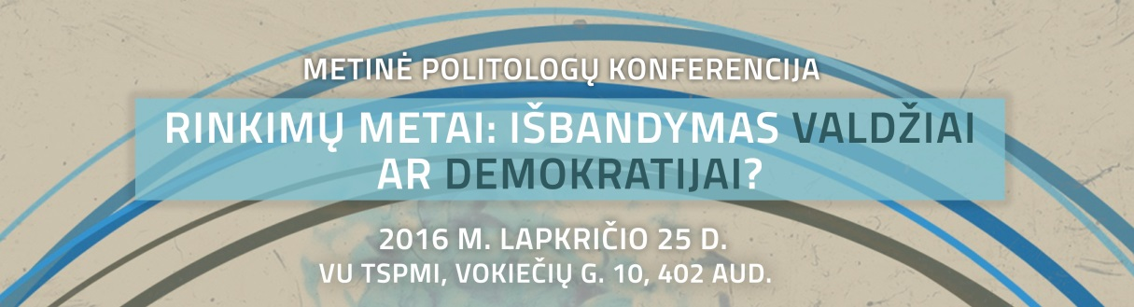
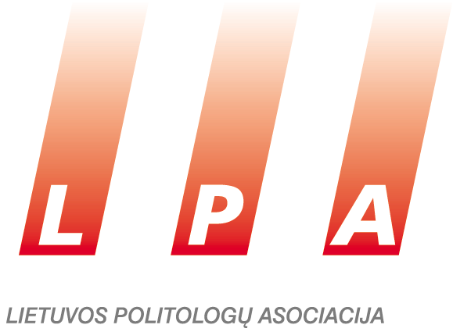
PROGRAMME
The Annual Conference of the Institute of International Relations and Political Science and the Lithuanian Political Science Association on Parliamentary Elections in Lithuania
November 25th, VU IIRPS, Vokiečių str. 10
9:30-9:45 | Opening of the conference  Ramūnas Vilpišauskas, Director, Institute of International Relations and Political Science, Vilnius University  Liutauras Gudžinskas, President of Lithuanian Political Science Association  Augustina Zamuškevičiūtė, representative of Konrad Adenauer Foundation office in Lithuania
9:45-11:15 | HOW DID VOTERS CHOOSE IN 2016?  Moderator: Jūratė Novagrockienė  Ainė Ramonaitė, “Voters turn to right or left? Lithuanian Peasants and Green Union‘s challenge to Lithuanian party system”  Ieva Petronytė, “Forgiving our own but not the strangers. Perception and evaluation of political scandals in Lithuanian society before the elections 2016 “  Mažvydas Jastramskis, “What can be predicted based on the voter turnout in Lithuanian elections? Myths and reality about the favour to the particular parties”  Laura Matjošaitytė, “What are the features of a voter in Parliamentary elections 2016? “  Comments (Mindaugas Jurkynas)
11.15-11.30 | Coffee break
11.30-13.00 | GEOGRAPHY OF ELECTORAL FIGHT: COMPETITION OR CONSALIDATION OF MONOLOPY?  Moderator: Ainė Ramonaitė  Rolandas Tučas, “The reform of boundaries of single-member constituencies in 2016: problems, progress, results”  Adelė Vaiginytė, “Tendencies of parliamentary elections: is there a risk for constituencies to become monopolies?”  Vaidas Morkevičius, “Do Lithuanian voters vote strategically? Divided voting in parliamentary elections”  Jonas Bačelis, Lina Kadžiulytė “Informational losses in vote counting process and unused opportunities of electoral system”  Comments (Zenonas Vaigauskas, Marija Šaraitė)
13:00-14:00 | Lunch break
14:00-15.30 | FORUM: WHAT HAPPENED TO REPRESENTATIVE DEMOCRACY IN LITHUANIA AND THE WORLD?  Moderuoja: Virgis Valentinavičius  Įvadiniai pranešimai:  Alvydas Jokubaitis, “Contradictions of representative democracy”  Jogilė Stašienė, ”Non-party candidacy -new formula for success?”  Diskusijos dalyviai: Alvidas Lukošaitis, Gintautas Paluckas, Vykintas Pugačiauskas, Jonas Survila, Tomas Tomilinas, Ramūnas Vilpišauskas
15.30-16.00 | Coffee break
16:00-17:30 | PASITIKĖJIMO KRIZĖ IR JOS INSTITUCINĖS PRIELAIDOS  Moderuoja: Algis Krupavičius  Liutauras Gudžinskas “Trust in enforcement authorities: Comparative Longitudinal analyses in Baltic countries”  Vitalis Nakrošis “Trust in Lithuanian civil service: functionality of interinstitutional relations and their influence to good governance”  Irmina Matonytė ir Vaidas Morkevičius, “The perception of threats to public welfare: effects of social optimism and personal, social and institutional trust”  Vytautas Kuokštis ir Romualdas Bakutis “Significance of tax morality, situation in Lithuania and the ways to improve it”  Comments (Ieva Petronytė)
17:30-18:30 | Refreshments

Organizers:

Kindly supported by:

