

THE 20th ANNUAL CONFERENCE OF CENTRAL EUROPEAN POLITICAL SCIENCE ASSOCIATION
Security Architecture in CEE: Present Threats and Prospects for Cooperation
Institute of International Relations and Political Science, Vilnius University,
Vokiečių str. 10, 25-26 September 2015

Organized by the Central European Political Science Association in cooperation with the Institute of International Relations and Political Science, Vilnius University and the Lithuanian Political Science Association.

Sponsored by the Lithuanian Research Council, the Ministry of National Defence of the Republic of Lithuania, the Ministry of Foreign Affairs of the Republic of Lithuania, and the Konrad Adenauer Stiftung
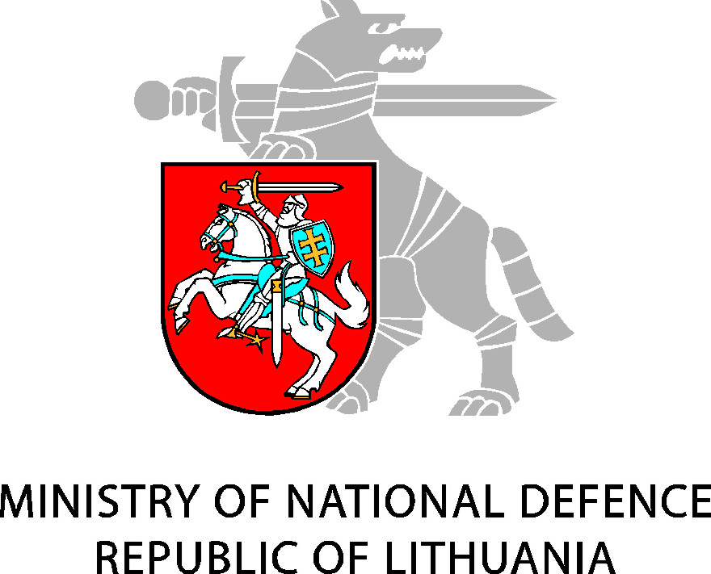
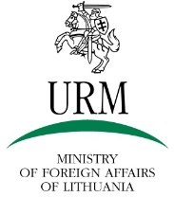


Friday, 25th September
08:30 – 09:00 | Room 402  Registration
09:00 – 09:15 | Room 402  Welcome speeches
09:15 – 10:45 | KEYNOTE LECTURE
09:15 – 10:45 | Putin’s Russia: a Challenge to Regional Security  Room 402  David Kramer
10:45 – 11:00 | Coffee break
11:00 – 12:30 | PARALLEL SESSION I
Panel 1.1 EU and its eastern partners: hurdles for closer cooperation | Panel 1.2 Contemporary issues in energy security and foreign policy implementation | Panel 1.3 Populism in party politics
Room 102  Chair: Dovilė Jakniūnaitė | Room 302  Chair: Gintaras Bagdonas | Room 402  Chair: Ladislav Cabada
Andrey Makarychev  The Ukraine crisis and new facets of borderland security: Estonia, Ukraine and Georgia in a comparative perspective | Giedrius Česnakas  Energy resources as tools of Russia’s foreign policy: types and effectiveness | Maria Daniela Poli  What does the “populism of the crisis” mean?
Mikheil Shavtvaladze  Democratic stability through consociational approach | Martin Jirušek  Risk assessment in natural gas sector in Central and Eastern Europe | Raimondas Ibenskas and Allan Sikk  Party instability in Central and Eastern Europe
Olga Bogdanova, Stefano Braghiroli  Democracy? Easier said, than done! Social capital and value-based civil society as key ingredients for democratic transition and consolidation in the post-Soviet space? | Hedvika Koďousková  Russian energy policy towards Asia: Case study of Gazprom | Andrea Fumarola  How important is political context? The determinants of electoral accountability in Central and Eastern Europe
Bruno Vandecasteele  The implications of Eurasian integration for the EU’s Eastern Partnership policies | Tomáš Vlček  Nuclear sector in Central and Eastern Europe: contemporary issues and patterns | Liudas Mažylis and Vaida Leščauskaitė  “Second order” features and “synergy” in voting campaigns in Lithuania in 2011-2014
 | Justinas Juozaitis  Lithuania’s national interests in energy policy of intergovernmental organizations: rationale, aims and accomplishments | Petr Voda  The evolution of “winners/losers” cleavage in the EU
12:30 – 14:00 | Lunch break
14:00 – 15:30 | PLENARY DISCUSSION I
14:00 – 15:30 | A partner or competitor: Attitudes of the CEE countries towards the EU – Russian relations  Room 402  Chair: Margarita Šešelgytė  Andres Kasekamp, Gediminas Vitkus, Andras Racz, Michal Šimečka, Dariusz Kalan and Eamonn Butler
15:30 – 15:45 | Coffee break
15:45 – 17:15 | PARALLEL SESSIONS II
2.1 Intersection of cyber and information security challenges | 2.2 The complex interplay across conflicts in the post-soviet space and the Baltic Sea region | 2.3 The next decade of ECE: the “Return to Europe” as a second try
Room 102  Chair: Nerijus Maliukevičius | Room 302  Chair: Jūratė Novagrockienė | Room 402  Chair: Gediminas Vitkus
Tomas Janeliūnas  Overlapping of cyber and information security challenges – from definitions to manipulations | Giorgi Kanashvili  Russian war in Georgia and its implication for security in the region | Attila Ágh  The historical trajectory of democratization in NMS: The decline of democracy and the Second Try in democratization
Teresa Sasinska-Klas  From soft power to the weaponization of information: Current trends in "non-linear war" between Russia and Ukraine | Remigijus Žilinskas  Co-operation of Lithuania and Poland in security and defence before and after crisis in Ukraine: Challenges, trends and prospects | Krisztina Arató  Civil society, social dialogue and social movements in Hungary: The changes under the second Orbán government (2010-2014)
Agnija Tumkevič  Cyber security in CEE: From risks to the security threats | Brent Hierman  The dragon in the bear’s den: Assessing Chinese interests and reception in Post-Soviet Central Asia | Klaudijus Maniokas  Post-accession changes in Lithuania: Achievements and pitfalls
Liis Vihul  Cyber conflict and international law: The Tallinn Manual Process | Gražvydas Jasutis  The potential for confrontation between Chechnya and Dagestan | Petra Vejvodová  Extremism and democracy: Forever in good or bad times
17:15 – 17:30 | Coffee break
17:30 – 19:00 | PARALLEL SESSIONS III
3.1 Energy security in Europe: Prospects and challenges for the future | 3.2 Issues of cooperation in security matters on the eastern littoral of the Baltic Sea | 3.3 Cohesive Europe, cohesion policy and comprehensive EU security
Room 102  Chair: Linas Kojala | Room 302  Chair: Giedrius Česnakas | Room 402  Chair: Darius Žeruolis
Ramūnas Vilpišauskas  Energy security and the Baltic Sea region: regional coordination and management of interdependence | Valentinas Beržiūnas  Cooperation of the Baltic States: Vacuum of strategic political cooperation and its consequences | Attila Ágh and Attila Kovács  The EU cohesion policy in the EaP region: External Europeanization in Wider Europe
Eamonn Butler  Challenges for energy integration in the European Union | Krzysztof Żęgota  The Kaliningrad Oblast and international security in the Baltic Sea region | Boglárka Koller  The differentiated integration revisited after ten years
Mesut Hakki Casin  How will the Ukraine crisis shape the future of European energy security? | Liudas Zdanavičius  The Kaliningrad oblast’ as a security challenge to the Baltic countries | Liutauras Gudžinskas  Strategic challenges of European integration: Lithuanian approach
 | Gerda Jakštaitė  Ukrainian crisis‘ impact on Baltic-US relations | Donatas Vainalavičius  Quest for a New European Strategy
Saturday, 26th September
9:00 – 10:30 | PARALLEL SESSIONS IV
4.1 Security dimension of Polish politics | 4.2 Czech party politics in flux | 4.3 At the geopolitical crossroads: Conflict in Ukraine
Room 102  Chair: Krzysztof Pałecki | Room 302  Chair: Vít Hloušek | Room 402  Chair: Bruno Vandecasteele
Tomasz Brańka and Jarosław Jańczak  Security discourses of the anti-systemic candidates in the Polish 2015 presidential election: European (in)security, Russian threat and the Ukrainian crisis | Ladislav Cabada  Populist parties as the winners of party system crisis in the Czech Republic? | Anton Bebler  On geopolitical aspects of the conflict over Crimea
Agnieszka Kasinska-Metryka  The issue of security as part of election campaigns in Poland and Spain | Vít Hloušek  Presidents against the parties: The role of influence of party politics by Czech heads of state | Andriy Tyushka  Hybridity trap for European security:  From Russian hybrid warfare in Ukraine to hybrid peace in Europe
Przemysław Żukiewicz  Between Russia and Germany. The security issue in the Polish presidential campaign, 2015 | Miloš Brunclík and Michal Kubát  Three technocratic cabinets as a symptom of Czech parties’ failure | Celeste Beesley  Divided preference on international relations in Ukraine: Clash of cultures or economic rationality?
Jacek Czaputowicz and Kamil Ławniczak  Polish international relations scholarly community and its distinguishing features according to the 2014 TRIP survey | Stanislav Balík  The weakening of political parties at the local and regional level: Causes and consequences | Valentina Teosa  Ukrainian dimension of Transdniestrian conflict in Moldova
 | Petra Svačinová  Factors influencing fulfilment of party mandate in the Czech Republic (2006-2015) | Roman Baecker  Evolution of Russian political system after February 2014
Petr Just
Populist and protest movements in 2013 parliamentary elections in the Czech Republic
10:30 – 10:45 | Coffee break
10:45 – 12:15 | PLENARY DISCUSSION II
10:45 – 12:15 | Development of political science in CEE over the last two decades  By CEPSA Presidents  Room: 402  Chair: Ainė Ramonaitė  Karin Liebhart, Silvia Mihalikova, Jerzy Wiatr, Ladislav Cabada, Attila Ágh
12:15 – 12:30 | Coffee break
12:30 – 14:00 | PARALLEL SESSIONS V
5.1 Army and politics in the 21st century: Changes within NATO and beyond | 5.2 National minorities in the context of national and foreign policies |  | 5.3 Intersection of influence of Russia and the EU in the post-Soviet space
Room 102  Chair: Karolis Aleksa | Room 302  Chair: Roman Baecker |  | Room 402  Chair: Miro Haček
Jerzy Wiatr  Army and politics: Theoretical paradigms and historical experience | Charles Francis-Xavier Szymanski  Schools, street signs and spelling names: The rights of the Polish minority in Lithuania under international law |  | Murad Ismayilov  Post-Cold War “new regionalism,” Western engagement with the post-Soviet, and entrenched postcoloniality
Jūratė Novagrockienė  The institution of conscription: The old wine in new bottles? | Andžej Pukšto  Polish ethnic minority and creation of bilateral relations between the Republic of Lithuania and the Republic of Poland |  | Vytautas Radžvilas  Dilemmas of CEE countries’ geopolitical identity in the circumstances of strategic battle for Eurasia
Deividas Šlekys  Understanding war and conceptual cleavage within NATO | Mindaugas Norkevičius  Attitude towards the Polish ethnic minority in Lithuania: Analysis of media public discourse |  | Stefano Braghiroli  MEPs' voting on and framing of Russia and the EU- Russia relations: Dr. Jekyll and Mr Hyde?
Lidija Čehulić Vukadinović  NATO beyond 2014: why open-door policy still matters? Western Balkans between Euro-Atlantic integration and Russia | Aleskandra Kuczyńska-Zonik  Russian minorities as an instrument of the foreign policy of the Russian Federation: Casus the Baltic States |  | Philip L. Crane  Europa Nostrum: How regional influence affects the neighbourhood
Sima Rakutienė
Eastern Partnership as international governance: Setting the role for the civil society
14:30 | Farewell

(Co-organizer/co-sponsor: Marie Curie’s International Research Staff Exchange Scheme (IRSES) project “Possibilities and Limits, Challenges and Obstacles of Transferring CEE EU Pre-Accession Best Practices and Experience to Moldova’s and Georgia's Pre-Accession Process” (EU-PREACC)

